***Medicare-Screenshot***

***Home Page :-***

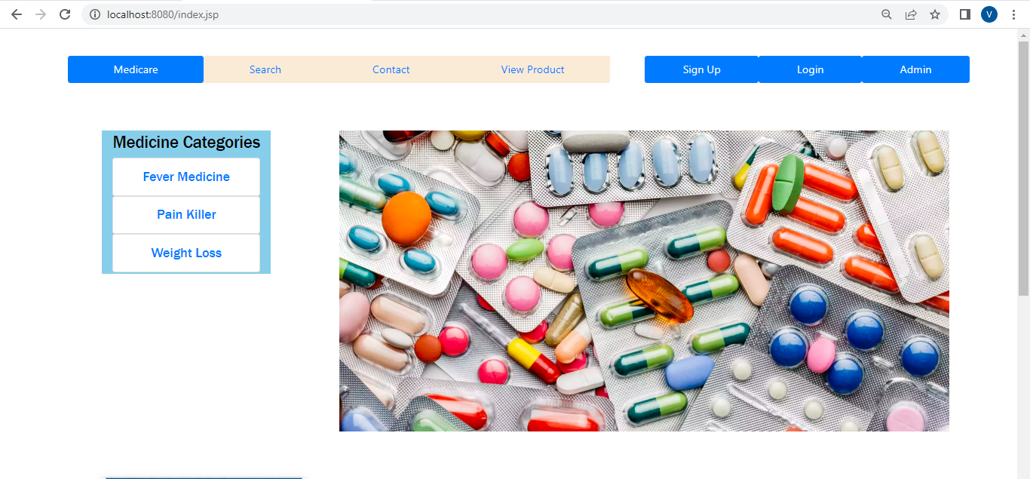

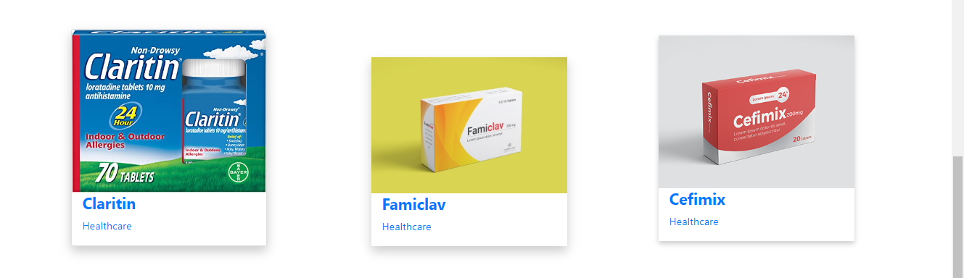

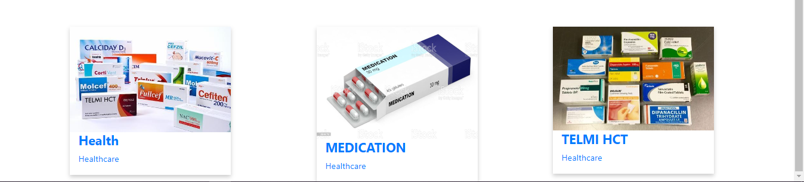

***User Register Page :-***



***Admin Login page: -***

